Università degli Studi di Napoli Federico II

Department of Data Science
Project Report
Comparative Analysis of two Agentic AI Information Retrieval solutions
(following homework “Agentic AI for Information Retrieval”)

For the course of Information Retrieval
Under the guidance of
Prof. Antonio Maria Rinaldi
Dr. Domenico Benfenati

Submitted by
Anindya Sunder Chakravarty (D03000004)

TABLE OF CONTENTS

1. Introduction 3
2. Data and Preprocessing 4
3. Retrieval Methodologies 7
4. System Implementation and Evaluation 11
5. Conclusion 28

1. Introduction
Ever since the advent of modern-day artificial intelligence, especially the rise of large language models, the paradigm of work has shifted tremendously. Automating tasks have never been easier and entities across the globe have been leveraging the power of AI and especially LLMs to solve problems that were considered practically unsolvable before. However, with the introduction of Agentic AI systems, the landscape has completely shifted. If LLMs are considered as the brain or the mouthpiece then Agentic AI is like granting it limbs so that it can perform tasks autonomously without human intervention.
Even in the field of Information Retrieval, not all tasks are mono directional, some require interaction and a back-and-forth participation between human and machine. For example, queries may contain multiple objectives or require information from different sources – what was not possible before can be achieved conveniently through the use of Agentic AI.
This project presents a comparative analysis between a retrieval augmented generation (RAG) system built over a static corpus and a crawling agent based on the Wikipedia API that can access data dynamically and in real time. To complete the application there are other sub agents as well such as the query handler which can autonomously transform the user’s query by extracting information and intent or the planner agent whose speciality is to develop a retrieval strategy based on the user’s information needs. Each approach has its own advantages and disadvantages as well as scenarios in which one will perform or suit better than the other.
Keywords: Agent, RAG, LLM, API, Pipeline, Wikipedia, Retrieval

2. Data and Preprocessing
As mentioned before, the project employs two different retrieval pipelines – one is a RAG system with static corpus, and the other is crawler-based retrieval agent.
2.1 Data Preprocessing for Static Retrieval System (Static RAG)
For the Static Retrieval Augmented Generation system, we decided to follow a hybrid approach – by applying dense and sparse vector searches and combining their results cleanly using Reciprocal Rank Fusion and then reranking using a cross-encoder model.
For the static retrieval system pipeline, the WikiText dataset was chosen from the provided project proposal, specifically because it provides wide ranging access to knowledge-based data, taken directly from Wikipedia which makes it perfectly suited to provide comparison for a Wikipedia crawler.
The dataset was obtained from the Kaggle platform (https://www.kaggle.com/datasets/vadimkurochkin/wikitext-103) and it was split in to training, testing and cross validation subsets. This type of splitting is usually done to train machine learning models, but since in our case we require only a static corpus to retrieve information from, it was decided that these three subsets be combined. Upon combination the corpus contained 29,558 articles.
Furthermore, upon inspection we noticed that each article, subtopic and subheading in the corpus had their unique delimiters - each article’s topic was denoted by = TOPIC NAME =; Each subtopic is denoted with = = SUBTOPIC = = ; and finally, each subheading is denoted as = = = SUBHEADING = = =. These structural elements will be used to preprocess the data.
2.1.1 Preprocessing the static corpus
As our first step towards preparing the data for eventual indexing, after we confirmed the structure of the document, with the help of regular expressions, we split each article and stored all of them in a list. Then created a new data structure – a dictionary that contained the text of each section under a subheading instead of entire articles plus that respective subheading, subtopic and article title. This was done as a pre-emptive measure before chunking. This step resulted in 256,982 sections. As an example:
{ "title": "Robert Boulter",
"sub_topic": "Career",
"sub_heading": "2000 – 2005",
"text": "Boulter began his career..." }

2.1.2 Chunking and Indexing
After this step, decided to investigate the number of words in each section’s text. We calculated the basic metrics such as mean, median and some percentiles to determine how the concentration of words were spread. From our analysis we discovered that the average section had approximately 400 words (388.4) and 95% of the sections had less than a 1000 words. The goal of this investigation was to help us decide on a chunking strategy.
The following visualization makes this distribution clear.
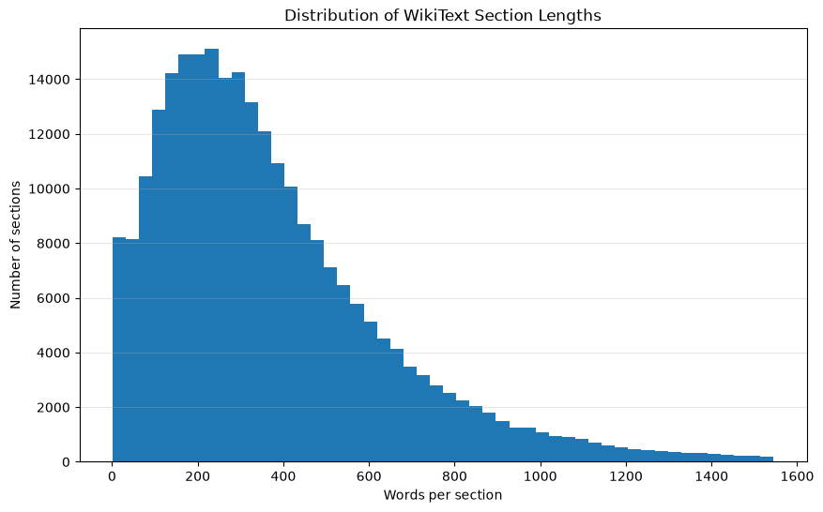
Histogram depicting the distribution of words in our sections.
Therefore, following the analysis, we decided to split our documents every 1000 words, which would mean only ~5% of the sections we extracted would have to be chunked the rest can be indexed as it is
Recursive Character based Splitting was chosen as the splitting/chunk method, since unlike fixed character size splitting, we can prevent chunks from being cut off mid-sentence or even mid-word. This ensures that we retain as much semantic meaning as possible in each chunk.
Thus, using the LangChain python library, we created 270,296 chunks (as opposed to 256,982 sections).
We then proceeded to build two different vector indexes – a dense vector index and a sparse vector index.
For the dense vectors, we utilized an embedding model from BAAI called bge-base-en-v1.5 to create 768-dimensional embeddings for each chunk. Vector embeddings can capture semantic similarities between words or sentences and have been the driving force in modern NLP development.
The dense vectors were created locally (using an AMD Radeon RX6900XT 16GB GPU in a macOS environment utilizing the Vulkan backend). Once they were created, we stored them in the FAISS Vector Index, a leading choice in embedding indexing. Down the line, FAISS is going to be our instrument to perform similarity searches on query embeddings.
Alongside dense vectors, we decided to also create a sparse vector index to help capture lexical similarity. Sparse vectors are particularly good with queries that contain keywords such as names, entities or phrases. We used NLTK python library to first tokenize our chunks to avoid classic NLP traps such as same words being considered as different words due to capitalization or punctuation – for example without tokenization, “Richard” and “Richard’s” would be considered different words by the sparse index therefore we could potentially miss important information. We store our sparse vectors as pickle files and will utilize BM25 as our retrieval mechanism.
2.2 Data Preprocessing in the Wikipedia Agent
The Wikipedia Agent does not have a conventional preprocessing or data ingestion pipeline since it does not operate around a static corpus. Therefore, much of the data preprocessing is done in real time.
When the Wikipedia agent is invoked, it begins by automatically searching Wikipedia with the search term deterministically (without an LLM’s oversight) and supplying the page selection subagent with search results. The subagent then decides which pages to follow and returns a list of pages.

2.2.1 Realtime data preprocessing pipeline
The data handling pipeline of the Wikipedia Agent then fetches the page’s HTML using their REST API. Then data preprocessing steps such as parsing the HTML using BeautifulSoup library, removing unnecessary sections from a page (such as “See also”, “References”) and unnecessary HTML containing scripts, styling, metadata, navigation, and other non-content elements. Furthermore, links from the pages selected are also extracted to be supplied to the agent
2.2.2 Localized retrieval as a form of filtering real time data
Instead of supplying our evidence evaluating agent with entire pages, we apply a form of localized retrieval using sparse vectors and reranking. This strategy was implemented to tackle ballooning token usage as each Wikipedia article could contain over 20,000 tokens.
Similar to our static corpus, we split each page into sections as dictionaries (we also include metadata such as title and subheadings).
Then, following the same strategy as our static corpus, we chunk each document (1000 words, recursive character text splitting) and index each chunk into sparse vectors.
We rank chunks using their BM25 relevance score by comparing with the seed query and supply only the top-k (20) chunks. Furthermore, we apply reranking using a cross-encoder model and filter out even more chunks leaving us with the most likely to be relevant documents as evidence (top 5).
2.2.3. Following links
Along with the chunks as evidence, a list of up to 30 links are also supplied to the evidence evaluating agent. These links were extracted from internal wiki-links elements and are represented by page titles.
During subsequent passes the agent can choose to follow up to 5 supplied links (URLs) contained within the page. During execution already visited links are always filtered out so that the agent does not keep bouncing between the same set of pages.
For example, in “Wars of the Roses” page we may find a link for “Richard III” and in “Richard III” we will find the link for “Wars of the Roses”, so without filtering we could be adding unnecessary latency and API costs to the application.

3. Retrieval Methodologies
As mentioned before, we are following two different pipelines and the retrieval methodologies implemented in both cases differ by a lot. For our static corpus-based operations, retrieval and ranking were the main objectives to accomplish whereas for our wiki agent, the central pillar to its functionality is an external service in the form of the REST API powering the agent.
3.1 Retrieval Methodologies for the static RAG
The retrieval pipeline of the static RAG remains very robust, thanks partly to its static corpus. We are primarily applying a hybrid retrieval approach in a sense that we utilise both dense and sparse vector retrieval along with neural reranking to return the most relevant chunks.
3.1.1 Dense Retrieval
As discussed above, each Wikipedia article is split into chunks and these chunks in return are computed as dense vector embeddings. Vector embeddings can capture semantic and contextual meaning to a certain extent, and we can perform similarity operations to compare how “similar” two vectors are. One of the most famous examples for this is that if we convert a corpus containing the words ‘Man’, ‘Woman’, ‘King’ and ‘Queen’, into dense embeddings, then we could perform an operation such as
$$King-Man +Woman≈Queen$$
This is the underlying operation that we leverage through the FAISS index – we already have our corpus as dense embeddings; we convert the user query into a dense embedding as well and then we perform similarity search and fetch the “vectors” that are the most similar to the query vector.
3.1.2 Sparse Retrieval
BM25 is the second retrieval methodology implemented in the system alongside dense retrieval. It represents the corpus using sparse lexical statistics and retrieves chunks based on lexical relevance with the query. This is a strong method to match terms and retrieve based on keywords such as names, entities etc. While dense retrieval captures the semantic meaning, BM25 complements our retrieval with lexical relevance comparison.
3.1.3 Hybrid system and Reciprocal Rank Fusion
After both phases of retrieval completes, we have two lists of candidates one from dense and one from sparse retrieval. However, there could be cases where both lists of candidates either do not share the same rank or are not present at all. That is where reciprocal rank fusion comes in:
$$RRF\left(d\right)= \sum_{r∈R}{\frac{1}{k+{(d)rank}_{r }}}$$
RRF is used to combine the ranked results of multiple retrieval techniques – instead of traditionally combining two scores from two different systems, RRF operates with ranks instead of scores and assigns each document a contribution based on its rank in each method.
Reciprocal Rank Fusion is the algorithm that enables us to follow this hybrid approach by helping us combine the results of the two systems.
3.1.4 Neural Reranking
A retrieved chunk can contain terms/keywords from the query, or it can be semantically similar without actually being useful to answer the question. Consider an example:
Question: “How did the wars of the roses end?”
Retrieved Document: “Historians often disagree how the wars of the roses ended”
In this example our retrieved evidence contains the relevant terms as well as is somewhat semantically relevant however it contributes nothing to the overall answerability of the question.
To solve problems such as the one explained above, we employ neural reranking, where specially trained models evaluate an evidence document by considering both the query and the candidate together. It is called reranking because we already have a ranked list of documents and this step acts as a further filter to only retain the most useful information.
In our case we used a cross-encoder model (ms-marco-MiniLM-L-6-v2) to do the reranking for us.
Therefore, our combined retrieval architecture becomes (1) Dense + Sparse Retrieval (2) RRF and (3) Neural Reranking.
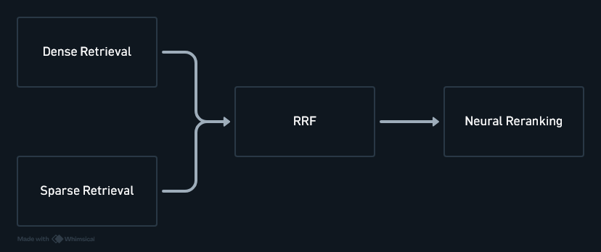

3.2 Retrieval with the Wikipedia Agent
The retrieval methodologies involving the Wiki Agent are fairly different as compared to a RAG working with a static corpus, since are dealing with real time data.
3.2.1 Wikipedia Search as the primary retrieval mechanism
When the Wiki Agent is first invoked, its first task it to perform a Wikipedia search through the API, since, unlike the static retrieval system, the Wikipedia Agent cannot depend on a static corpus, since the corpus is technically endless in this case. Therefore, this specific functionality – provided by a third-party service – is the key to the Wiki Agent’s retrieval capabilities.
The search is performed automatically and deterministically (without LLM intervention) when the wiki agent is invoked using a seed query. The search results are then collected and supplied to a page selection agent which then proceeds with the rest of the operation. The search results themselves are a list of dictionaries containing information such as page title, page ID, description and a small excerpt from the page.
A failure at this step is fairly hard to recover for the agent as seen in this example:
Question: Who is the mother of the director of film Polish Russian War (Film)?
This is the Agent’s behaviour:
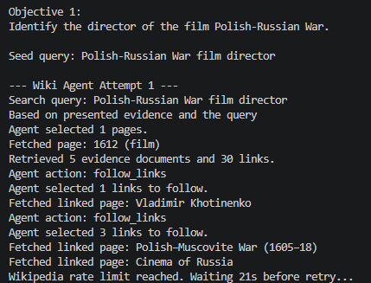
However, upon further investigation, perhaps due to the highly ambiguous nature of the question, even the actual Wikipedia website couldn’t return the proper search result for this exact film.
3.2.2 Localized retrieval over real time information
As briefly mentioned in the previous section, once a page is selected by the page selection subagent, we once again employ the Wiki API to fetch the selected page‘s HTML. After preprocessing the data to extract the content of the page, i.e., the Wikipedia article, we further divide it into chunks and then BM25 is applied (chunks are tokenized using NLTK) as a sparse retrieval mechanism to rank the chunks’ relevance according to the current seed query. Furthermore, we employ neural reranking using a cross-encode reranking model further filter our chunks into top 5 most relevant chunks.

This mechanism was introduced to reduce API costs, latency and manage context windows as simply supplying the evidence evaluating subagent with entire Wikipedia pages could mean a usage of up to 100,000 tokens for 5 complete pages.

4. System Implementation and Evaluation
In this section we will discuss how the system is designed, how each individual component is and interface with one another.
4.1 System Architecture – Bird’s Eye View
There are three main architectural principles followed throughout this project – the first one is separation of responsibility. There are multiple subagents involved in the system and their responsibilities have been clearly defined and separated. The second principle is the implementation of deterministic logic and control wherever possible, especially to keep the LLMs and their behaviour in check. The final principle is iterative functioning – wherever the chance presents itself iterative refinement has been employed, for example, in the query handler module, the model would reason if the user provided query is enough or if it needs further clarification, or like the Wiki agent which reruns its retrieval system if it deems the evidence is not enough.
Below are the core components of the system followed by a brief explanation for each. Later we will discuss each component in detail.
4.1.1 Core components of the system
- Query Handler – It is a component responsible for interpreting the user’s query, deciding if there is any further need for clarification, decomposing the query, extracting information and producing a structured output to be used by the planner.
- Planner – Receives a decomposed query and extracted information from the query handler. Its main responsibilities are to build a retrieval strategy, create objectives based on the information need, compose seed queries for the retrieval system, interface with the retrieval system and answer generation engine to capture intermediate answers that are needed for further objectives and finally invoke the answer generation agent once evidence for the query has been gathered.
- Retrieval Tools – As discussed above, we are employing two different types of retrieval tools in two pipelines:
- The first is a hybrid retrieval system for a static corpus, the WikiText dataset
- The second is a Wikipedia agent operating around the REST API service. Its primary task is to search Wikipedia for a seed query, extract information, follow different pages and deliver enough evidence to answer the seed query.
Both these tools could be invoked multiple times depending on the number of objectives and therefore seed queries.
- Answer Generation Engine – The answer generation engine is primarily responsible for interacting with the user. Therefore, it has been specially instructed to ground its answers with the evidence that has been supplied. Its other duties include asking the user for clarification in case it is needed by the query handler and generating intermediate responses needed to fulfil subsequent objective from supplied evidence.

Below is a visual representation of the entire system:
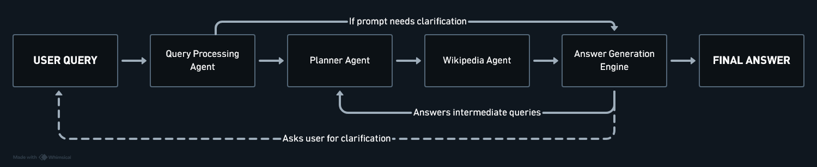
Now let us explore each component in detail and understand how they function and interact with other components in the system.

4.1.2 Query Handler
This is the first LLM based component in our pipeline. Its primary objective is to understand a user’s question or query, extract information from the prompt for retrieval purposes and return a structured packaging all the information it has gathered. It also has a secondary objective which is to invoke the answer generation engine to interface with the user and ask further clarification on the user’s query. Below is the internal design flow of the component:
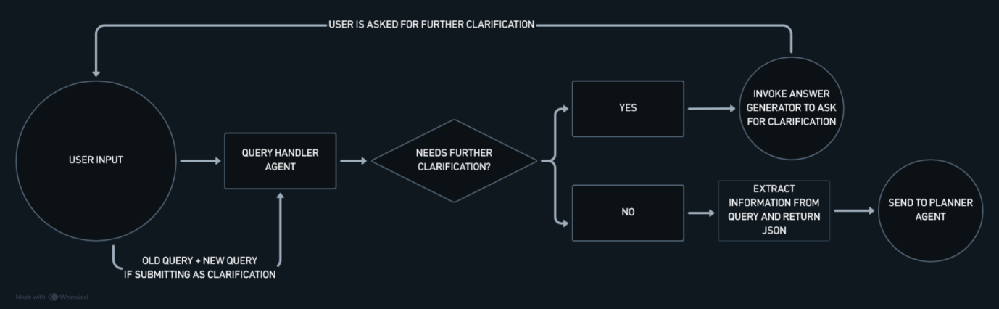

- Input – This is the entry point to the pipeline – it receives the user’s original query as a string.
- Clarification Loop – Its first instruction is to analyse the user’s prompt and decide if there is a need for further clarification. If there is then it returns a structured output indicating the same (‘status’: ‘clarification_required’) and the control logic invokes the answer generation module to ask the user for clarification. The query handler does not process each clarification independently, instead it is stateful, i.e., for each subsequent clarification request it is supplied with the old message as well. Consider the example:
User: Who was he fighting against?
LLM: Needs Clarification.
User: Napoleon.
LLM: Receives both Napoleon as the clarification and the original user query as context.
Statefulness for this mechanism was compulsory as without retaining state it cannot comprehend the sole meaning of “Napoleon” the second time.
- Hard termination control – The entire clarification loop is controlled by a hard limit set in the control layer of the program. This ensures that we are not stuck in a perpetual clarification loop. In the event when the clarification limit is hit, the program is terminated through the control layer.
- Once it is determined that the query is enough, it is instructed to extract different information that can be used for retrieval downstream such as
A) Intent – Describes the information needed
B) Entities – Identify people, organizations, locations etc.
C) Concepts – Identify topics, phenomena etc.
D) Relationships – Map a relationship between entities or concepts following the structure of subject-object-relationship.
E) Query – It is instructed to retain the user’s query verbatim
F) Status – This variable is used to identify if clarification is necessary or if information extraction was successful and we are ready for the next step.
- These fields are packed and returned as a JSON object only.
- The LLM is prompted using few shot prompting.
4.1.3 Planner
Planner is the component that comes right after the Query Handler is primarily responsible for building a retrieval strategy, forming objectives and drafting seed queries. Query Handler determines what the user is asking while planner determines what is the best way to answer the user's query. Its input is the query handler's output - a structured object containing the original query and additional information.

- The planner produces a retrieval plan containing a list of objectives. Each objective is a specific information requirement. Each seed query generated is a query that will be used to invoke retrieval tools/agents.
- Through prompting the planner's central LLM has been instructed to only create multiple objectives when there is a need for sequential retrieval such as in the case of multi hop question.
- The planner also includes fields (depends_on and {previous_result}) that support fulfilling dependent objectives. Consider this example: Where was the current President of Italy born? It might decide -
objective 1: Who is the current president of Italy
objective 2: where was {previous answer} born? (so now objective 2 is dependent on objective 1)
Through this mechanism, the planner supports sequential types of questions such as multi hop. Below is a sample planner output highlighting the points discussed above
{
"objectives": [
{
"objective": "Who is the current president of Italy.",
"depends_on": [],
"seed_queries": [
"Current President of Italy"
]
},
{
"objective": "Where was the person referred to in Objective 1 born?",
"depends_on": [1],
"seed_queries": [
"{previous_result} birthplace"
]
}
]
}

- Seed queries and retrieval: Each retrieval objective can contain one or more seed queries. The planner generates these seed queries which are then passed to respective retrieval blocks (RAG or Wiki Agent) for evidence retrieval.

- How are answers generated?
A) When the query is straightforward, i.e., there is one objective and one set of seed queries, the control layer extracts the seed queries from the structured output of the planner and invokes the retrieval layer for each seed query. Once the retrieval layer returns evidence for all seed queries, all the accumulated evidence is then supplied to the answer generation engine to generate the final answer. Since the "depends_on" field was empty for a query with no intermediate objective the control layer can use that to identify and directly call for the final answer to be generated.
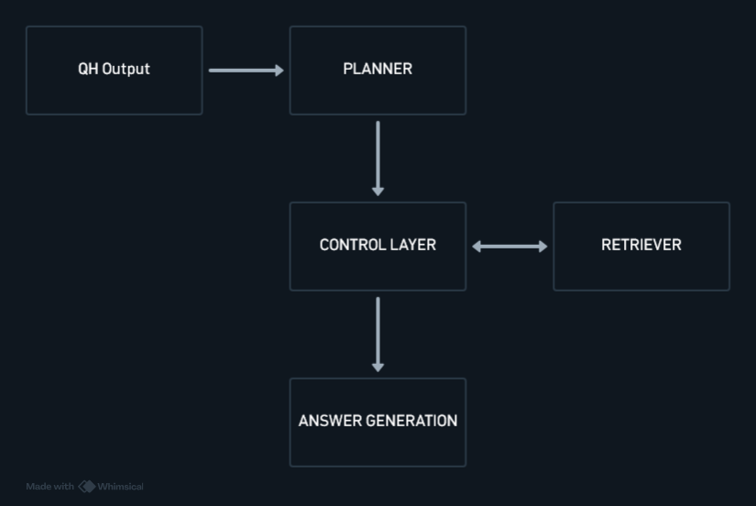
B) When the query is complicated and has multiple objectives, then the control layer extracts the first set of seed queries (again identified by the empty "depends_on" field, first objective is always empty), feeds them to the retriever one by one and gathers the evidence supplied. This evidence for the intermediate objective is then sent to the answer generation by calling a special function (generate_intermediate_result) which instructs the LLM to only return the minimum piece of information required based on the evidence supplied. Once this minimal answer is fetched it is replaced in the secondary objectives' seed queries' special field - '{previous_result} birthplace' -> 'Sergio Mattarella birthplace' and this new seed query is sent for retrieval and once all the objectives are complete, we send the evidence for answer generation.
Considering the previous example:
- objective 1: Who is the current president of Italy
- O1 seed query: current president of Italy
- Sent to retrieval->evidence gathered is sent to intermediate answer generation-> answer received: Sergio Mattarella
- objective 2: Where was the person being reffered to in Objective 1 born?
- O2 seed query: where was {previous answer} born? becomes -> where was Sergio Mattarella born?
C) Therefore, in conclusion, the planner actually only runs once and returns a detailed retrieval strategy. The control layer, through careful recursion is able to complete the multi-objective, retrieval strategy.
Refer to the chart below to see how the workflow is generated.
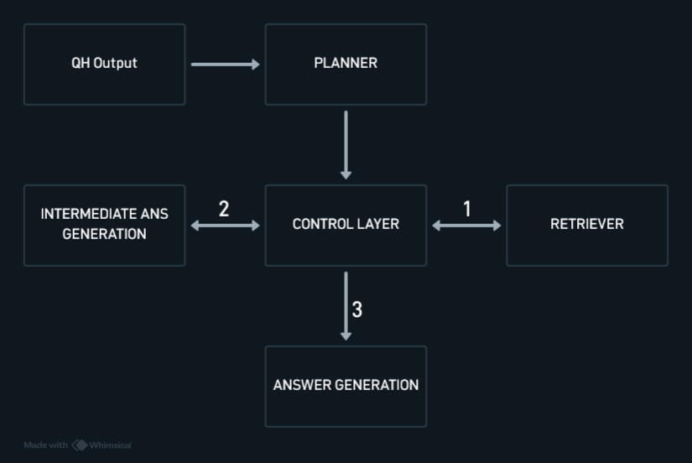

4.1.4. Wikipedia Agent
The Wikipedia Agent is a retrieval agent built on top of Wikipedia’s REST API service. Its core responsibilities include searching Wikipedia with a seed query, selecting the most relevant pages, fetching and parsing the page data, retrieving and ranking evidence from the gathered page data, extracting links from pages, evaluating if presented evidence is sufficient to answer seed query, choosing to follow links to other pages, choosing to rewrite query if evidence is insufficient. The flagship feature of this agent is its very pronounced Observe-Plan-Act-Validate loop.
The application is divided into multiple modules each with its unique roles such as orchestration, communicating with the Wiki API, parsing responses, logging etc.
How does it work?
- Upon invocation of the agent, it is supplied with a single seed query (due to Wikipedia’s rules on API usage we did not implement parallel seed query processing) and it performs its first Wikipedia search deterministically.
- The search results contain the title of the article, page ID, a small description and an excerpt from the page. These results are submitted to the page selection subagent (currently it is set to up to 5 search results) which identifies the most relevant pages and returns a list of page IDs.
- These IDs are then used to fetch Page HTML, which is then parsed, pre-processed into dictionaries and are chunked while useful links (currently we allow up to 30 links to be selected) are extracted and filtered for subsequent exploration.
- The chunks are then ranked through BM25 and subsequently filtered using neural reranking, producing a small set of highly relevant chunks (currently we send 5 best chunks).
- These chunks are now treated as evidence candidates to answer the current seed query and passed to the answer evaluation subagent along with the extracted links. If the evidence is judged to be sufficient then execution of the pipeline is terminated and current evidence is sent for answer generation.
- If it is judged insufficient then the agent has two choices – either to follow the links previously extracted from the page or rewrite the query.
- If it chooses to rewrite the query, then it initiates another Wikipedia Search and the whole process is repeated again.
- If it chooses to follow links (up to 5) then each page’s HTML is fetched as explained above and the process repeats from there. However, the control layer maintains a copy of the visited links and every time before presenting the agent with new links it removes the ones that have already been visited. Thus, we are able to maintain a history of links or rather avoid visiting old links again.
We can visualize the system design through this chart:
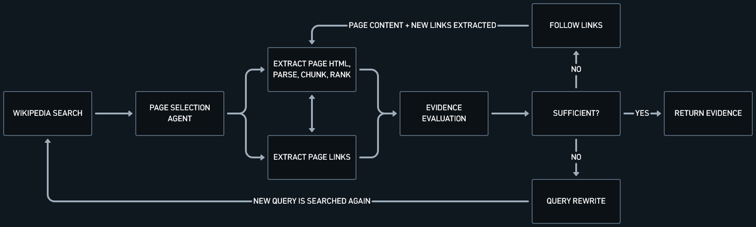
Salient Features:
1. Controlled Exploration – There are hard termination limits in place which control the behaviour of the LLM such as maximum search attempts, maximum link following iterations (how many times the agent can choose to follow links, currently 3), maximum links per iteration (how many fresh links the agent can choose every iteration, currently 5) and number of links supplied to the agent (first 30 links). Moreover, there is a “visited links” filter which removes the links already visited before the top 30 links are submitted to the agent.
2. Focus on controlling API costs – In order to control ballooning token usage, it was decided to supply the evidence evaluator with the most relevant chunks instead of the entire page’s contents. But our scoring methodology is based on lexical statistics (BM25) + reranking which could affect our performance.
3. Logging and Data persistence – The final set of evidence is saved in the wiki-data.log files. The pipeline’s execution trace is captured and logged as well, capturing important information such as pages and links visited.
4. State handling: There are two kinds of state being maintained by the agent – “local state”, handled in the deterministic logic of the control layer – things such as visited pages, evidence from previous retrievals, current link iterations, etc. The second kind is conversational memory which is only used for the query rewriting subagent – it receives the current “bad” query, the reason for the rewrite request and previous rewrite history. This is done so that the subagent does not similar/identical search terms as it has done before.
5. Wherever applicable, all LLMs are prompted using few shot prompting.
Following Wikipedia API etiquette (for a lack of robot.txt)
The agent, thanks to its massive autonomy, is capable of making multiple requests therefore Wikipedia’s suggestions on API usage were followed to a great extent.
A. Setting a user agent to identify we when making requests. This is an explicit rule barring which we would be severely rate limited.
B. Sequential Requests – Unlike our RAG pipeline, we use only sequential requests to fulfil our data needs.
C. There is a delay programmed between each request.
D. As a byproduct of our hard termination limits, we have reduced the number of requests made by limiting unnecessary wandering.
E. Applied Exponential backoff with a maximum of 3 retries including utilising the retry-after value as suggested by Wikipedia.

4.1.5 Static RAG
This project is primarily based on the comparative analysis of both an API based agent with no specific dataset and standard RAG system with a static corpus.
RAG Systems with a static corpus have numerous uses, chief among which is the capability of using private documents (along with a private AI provider). However, its biggest weakness is also its static data. There has to be set protocols for maintaining data versions, converting new data into vector indexes etc.
The Static RAG implementation in this project follows the conventional two step architecture – it creates vector indexes from the data before any retrieval tasks occur and during retrieval it uses the vectorized query to compare and retrieve the most relevant chunks.
The workflow of this system remains fairly straightforward:
1. Receive seed query from planner agent
2. Send the query for both dense and sparse retrieval and process accordingly for each method.
3. Retrieve list of documents from both retrievals.
4. Use RRF to combine the ranked list of documents.
5. Pass fused list of documents for reranking
6. Retrieve the corresponding documents and return them as final evidence for query.
Similar to the Wiki Agent this module acts as only the retrieval mechanism, therefore, the other agents are still utilized to fulfil their roles.
Parallelization
Unlike our compulsion of using only sequential operations for the Wiki Agent due to their usage guidelines, here we are free to optimize, therefore both parallelization and OOP principles were applied to save valuable execution time.
1. During retrieval, we must load both FAISS and BM25OKPI indexes, along with the actual chunks themselves. In addition, we must also load our embedding and reranking models for each query. Therefore, all these files are now being loaded in parallel and since a class has been implemented, during execution, the object can be instantiated once for multiple queries.
2. Again, during retrieval dense and sparse retrieval can be parallelized before eventually rejoining a sequential pipeline of RRF and then reranking. Therefore, both retrieval processes have been parallelized. We will investigate their effectiveness in the evaluation section.

4.1.6 Answer Generation Engine
The primary role of the answer generation engine is to generate the final answer by strictly grounding it to the supplied evidence and in accordance with the user's query. Even though narrow in implementation, this module will generate the final answer and interface directly with the user, therefore it is a critical feature in the architecture.
However, in our case, we have created two different functions that enable us to use this module with other agents to either ask the user for clarification on queries (for query handler) or even generate intermediate answers (for planner).
For each task, there are separate prompts, following separate strategies. However, all three have been instructed using few shot prompting. The model is allowed to reason internally but not allowed to expose its reason in the final answer.
Following the general theme of the project, separation of concerns is applied here as well. This module serves only to generate text based on evidence or interface with the user. It has no state of its own and has no access to any other tools.
4.1.7 LLM Service Provider Interface
In order to set the project up as model agnostic, a special layer for the service provider has been created so that we can switch service providers between a locally hosted LM Studio server and a cloud API based inference provider called OpenRouter without influencing any of the code in the project. This was its sole purpose.
Additionally, the OpenRouter server can be accessed by saving the API key in an environment file, changing the value of “GLOBAL_PROVIDER” variable inside llm_router.py to “OR” and correctly specifying the model’s name and the API access URL inside open_router_server.py.
This project has been done completely on a locally hosted model and LM Studio server.

4.2 Evaluation – LLM-as-a-judge RAGAS inspired evaluation framework
The evaluation system was based on benchmarking the system with 100 questions from the 2WikiMultiHopQA dataset (https://arxiv.org/abs/2011.01060) via HuggingFace, covering different types of questions such as compositional, inference, bridge comparison etc. This system was applied to both the static RAG and the Wikipedia Agent.
The entire project was undertaken with a locally hosted model via LM Studio server. Below are details related to this:
Model(s) Used : Qwen 3.5 9B (both for application building and evaluating)
Computer Specifications:
CPU: Intel Core i5 14400F (10 cores (6P+4E), 12 threads)
GPU: AMD Radeon RX 6900XT 16GB
RAM: 32GB DDR4 3600 MT/s
Backend: Vulkan
Four distinct areas were focused on matching the 4 unique agents present in the project: Query understanding, planning, evidence retrieval, and answer generation.
This evaluation system was inspired by the RAGAS metrics with an LLM-as-a-judge:
1. Query understanding was evaluated through intent, entity, concept, relationship, and completeness scores.
2. Planning was evaluated according to objective decomposition, dependency identification, seed-query generation, and execution.
3. Evidence was evaluated using context precision, context relevance, context recall, and evidence sufficiency.
4. Generated answers were evaluated for faithfulness, relevance, and correctness

We calculated a score for the component only when the component finished execution in the pipeline, that allowed us to measure the scores of components even when the pipeline eventually failed.
In addition to RAGAS inspired metrics, system metrics such as latency was also recorded. Total token usage was attempted but ultimately not undertaken with this version of the project.

4.2.1 Results - Static RAG
Component | Score
Query Handler | 0.898
Planner | 0.722
Evidence | 0.075
Answer | 0.620
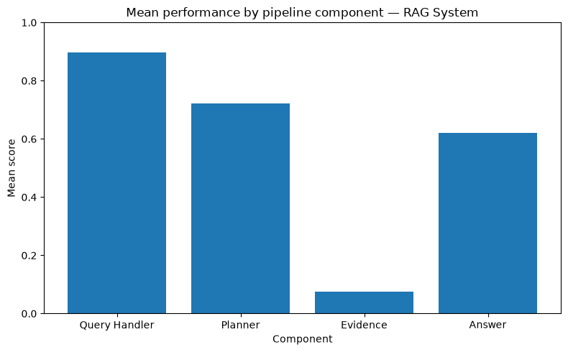
The static RAG system displayed strong performance in query handling and planning. In contrast evidence retrieval was exponentially weaker. Answer generation performed above average leading to conclusions that when the system had enough evidence the answer generation engine remained grounded.

Looking at individual scores:
- context precision :0.104
- context relevance 0.095
- context recall 0.051
- evidence sufficiency 0.049
- Answer faithfulness 0.820,
- Answer correctness was only 0.331.

This suggests that generally the system answered mostly based on grounded evidence as we can infer from Answer Faithfulness, but the evidence for the most part was either missing or low quality.
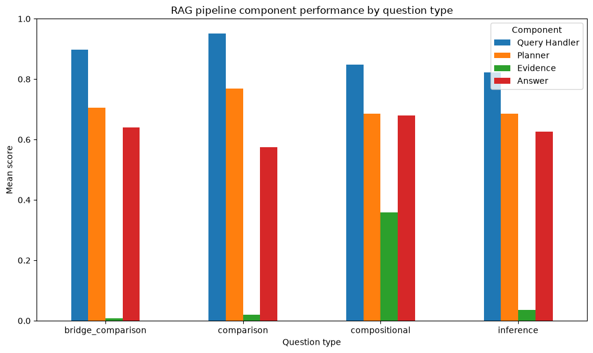
Thus, for the Static RAG the primary limitation is strongly evidence gathering. As for hypothesising the reasons, two points can be considered in conjunction:
1. A static RAG’s greatest weakness is its static corpus. Our dataset has less than 30,000 articles and,
2. Inspecting log files further confirms that for a lot of questions there simply isn’t enough data in the dataset.
Looking at End-to-end latency:
count 100.000000
mean 102.622780
std 182.358212
min 29.595523
25% 40.123585
50% 45.745559
75% 62.803033
90% 123.421803
95% 552.313858
99% 1020.804295
max 1052.445034
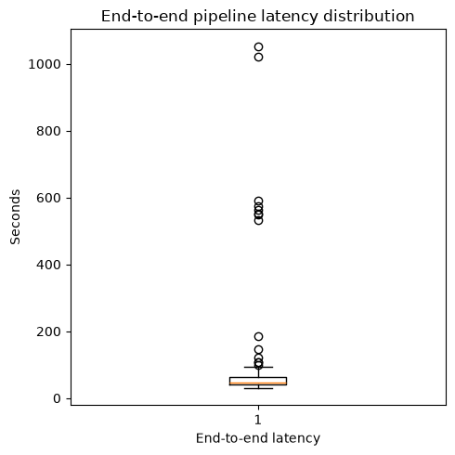
We can notice that about 75% of the operations take approximately 1 minute to conclude. Also, there is a huge gap between mean and median meaning that we have a skewed distribution.
4.2.2 Wikipedia Agent
Since we are using the same agents except for the retriever, we had similar scores across the board:
Component | Score
Query Handler | 0.897
Planner | 0.796
Evidence | 0.586
Answer | 0.744
We can notice a similar pattern here – across the board the pipeline performs really well however when it comes to evidence it starts faltering. Let us look at individual scores now:
Metric | Score
Context precision | 0.661
Context relevance | 0.640
Context recall | 0.526
Evidence sufficiency | 0.518
Metric | Score
Faithfulness | 0.858
Relevance | 0.818
Correctness | 0.554
From RAG to Wiki, the story changes considerably, however the broader issues of evidence gathering remain. Although in comparison, evidence related scores have gotten much better but that is to be expected since the Wiki agent as access to real time dynamic data.
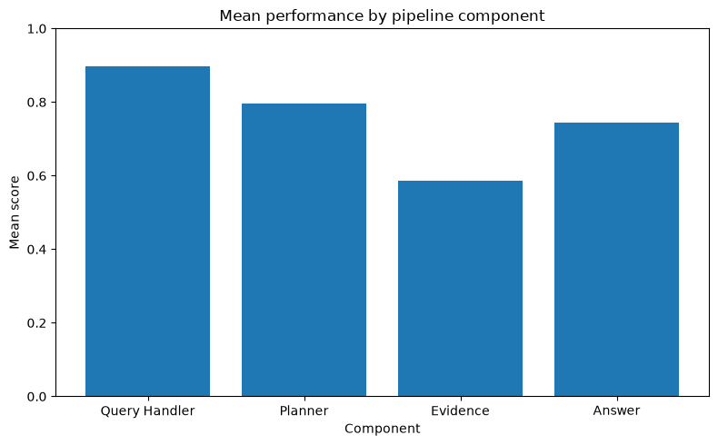

The performance trends were further clarified when we looked at evidence per question type – performance was better for composition and inference questions, but questions requiring multiple pieces of information struggled.
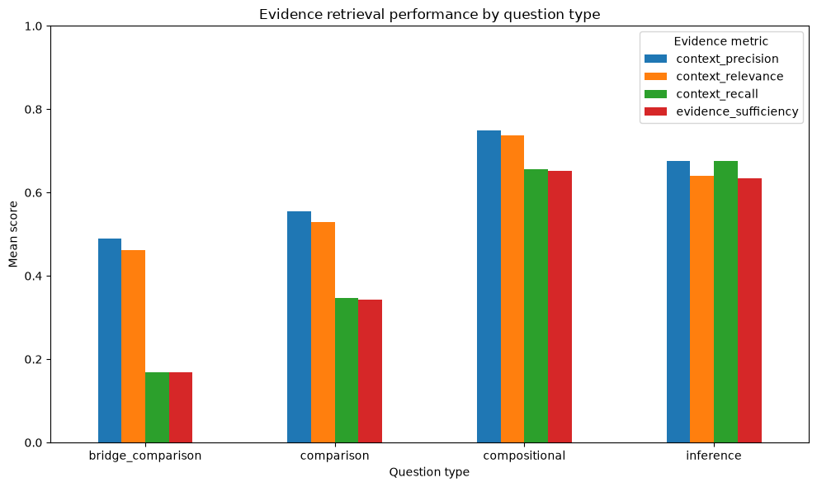

Looking at end to end latency for the wiki agent:
mean 263.403696
std 434.427346
min 41.153935
25% 95.527899
50% 129.145573
75% 205.603528
90% 632.990520
95% 682.602564
99% 1168.444737
max 3953.453981

Similar to our RAG system, mean and median are far apart signalling a skewed distribution.
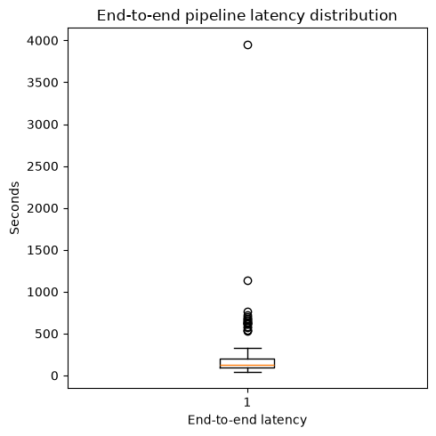

4.2.3 Comparison – Static RAG and Wikipedia Agent
First let us compare the per component score and some of the evidence-based scores:
Metric | Static RAG | Wiki Agent
Query Handler | 0.898 | 0.897
Planner | 0.722 | 0.796
Evidence | 0.075 | 0.586
Answer | 0.620 | 0.744
Context recall | 0.051 | 0.526
Evidence sufficiency | 0.049 | 0.518
Answer correctness | 0.331 | 0.554
We can notice straightaway that our Wikipedia agent is beating the static RAG in evidence gathering. This is further proven by the fact that answer correctness is also increasing. However, the Wiki Agent’s score in and of itself is not too encouraging. There are two identified bottlenecks in the system which could be throttling our performance:
1. Wikipedia Search – there have been multiple cases where either ambiguous or obscure terms were encountered in the benchmark dataset and Wikipedia search was unable to resolve the issue even with deliberate help from the user.
2. Real time retrieval system – Instead of feeding the LLM the selected pages’ full content, we are only feeding it chunks based on BM25 scoring and reranking. That can prove to be a huge bottleneck.
Comparison – End-to-end latency
As we can see the static RAG’s median latency was 62s whereas the wiki agent’s was more than double at 129s. In fact, across the board the Wiki agent is considerably slower than the static RAG system. Two primary culprits present themselves:
1. Delays caused by following Wiki API’s etiquettes – exponential backoffs, delays between searches, rate limitations etc. all contribute heavily towards system latency.
2. Another issue with the testing setup is that the Qwen family of models are particularly favourable towards thinking more than the task demands it. So, model choice could another culprit for latency.
3. As for the Static RAG, it had the added advantage of parallelism aiding its efforts.

5. Conclusion
To conclude, we have gone through two different implementations of information retrieval through agentic systems. Our first pipeline implements a conventional vectors-based RAG over a static corpus, while our Wiki Agent primarily deals with real time and dynamic data.
For both systems, we used some common agents and tools, namely:
1. Query Handler which interprets a user’s query and extracts information from it. In cases where the query is incomplete or ambiguous, then the Query Handler requests for clarification.
2. The Planner agent receives the decomposed query from the query handler and works to build a retriever strategy. Its main purpose is to build a strategy, determine intermediate objectives, design seed queries and execute retrieval steps.
3. Static Retrieval – This pipeline queries the locally built hybrid index. It follows a 2-step architecture – the static data was converted to dense and spare vectors and then combined and reranked before any inference or retrieval was made. During inference the user’s query is used (as an embedding) to search for the most relevant chunks and return it as evidence.
4. Wiki Agent – This Agent, primarily based on the REST API service provided by Wikipedia, works as a real time retrieval mechanism. It is capable of retrieving page and parsing page data, following page links, can course correct itself through its own query rewriting subagent.
5. Answer Generation Module – It is supplied with retrieved evidence and the user’s query, and its only task is to answer the question based on the evidence provided.
6. Evaluation – Through evaluation we discovered that all the components of the system are functioning exceedingly well other than the evidence retrieval systems – particularly the static RAG performed poorly on the benchmarking dataset.
5.1 Future Work
As pointed out above, there are immediate problems in the system which warrant at least a detailed inspection – especially our static RAG system.
The first test could be changing the benchmarking dataset but even that is less likely to help since our corpus is limited. Therefore, rebuilding the indexes on an offline benchmarking corpus and then evaluating should be the first step.
As for the Wiki Agent, the first step would be to tweak or change the inline real time retrieval in order to hopefully see changes in retrieval and evidence-based performance.

